Term | Start | Half Term | Start Back | End
Autumn | 9th of September 2019 | 21st-24th of October  2019 | 28th of  October  2019 | 19th of December  2019  Christmas
Spring | 6th of  January  2020 | 17th-20th of February  2020 | 24th of February  2020 | 2nd of  April  2020  Easter
Summer | 20th of  April  2020 | 25th of May -28th May  2020 | 1st of  June  2020 | 2nd of  July  2020  Summer
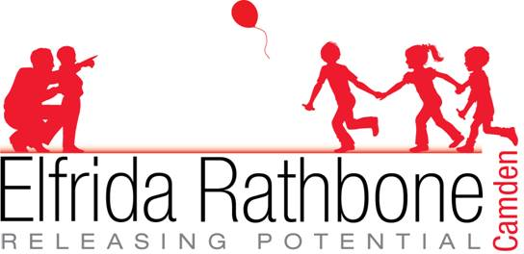
Leighton College Term Dates 2019-2020

